Block diagram screenshot

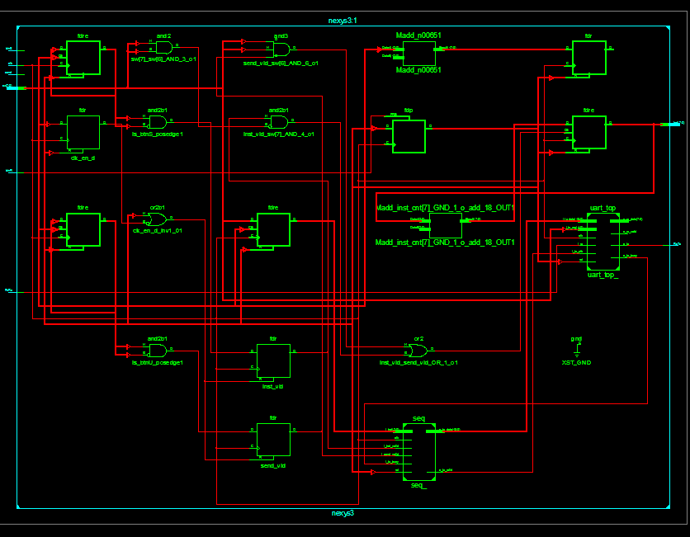

Console output for Fibonacci sequence:

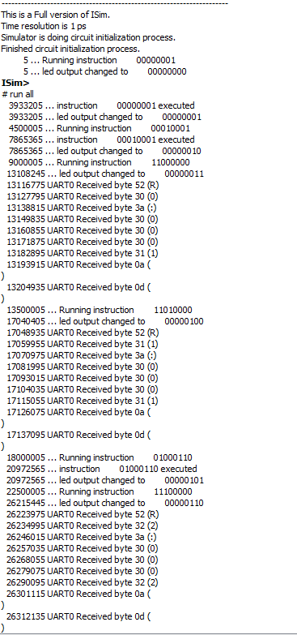

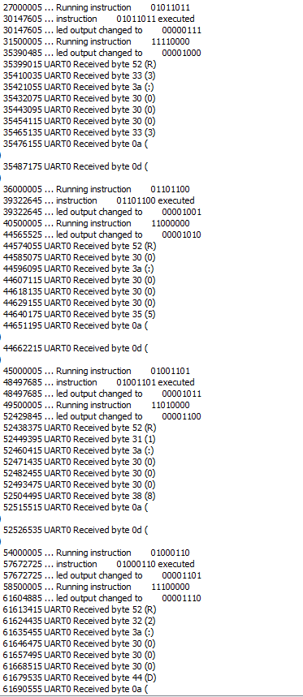

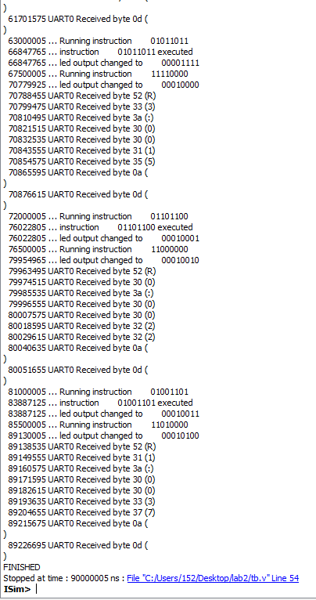

Waveform for fibonacci zoomed in to memory lines that are relevant:

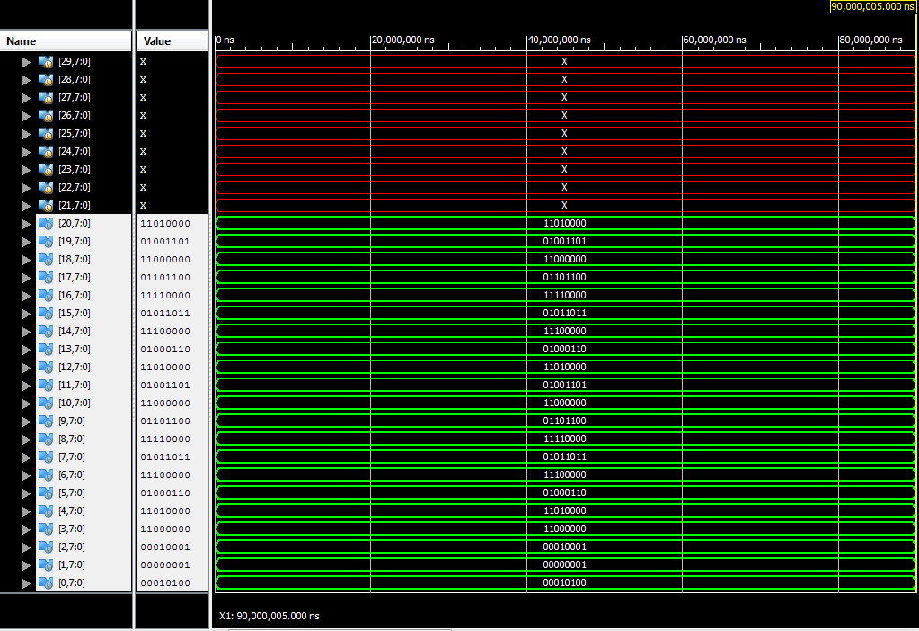

Waveform of everything for Fibonacci:

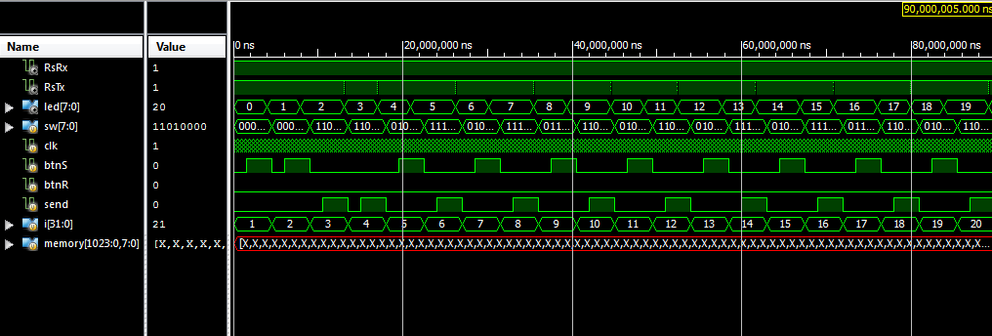

Console for sampleSeq.code:

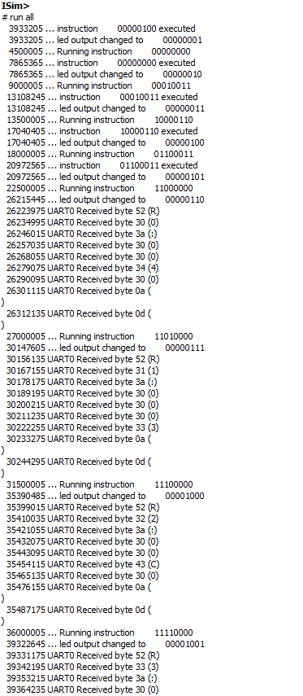

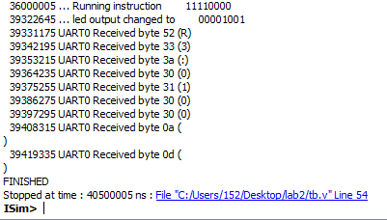

Waveforms for sampleseq.code (memory):

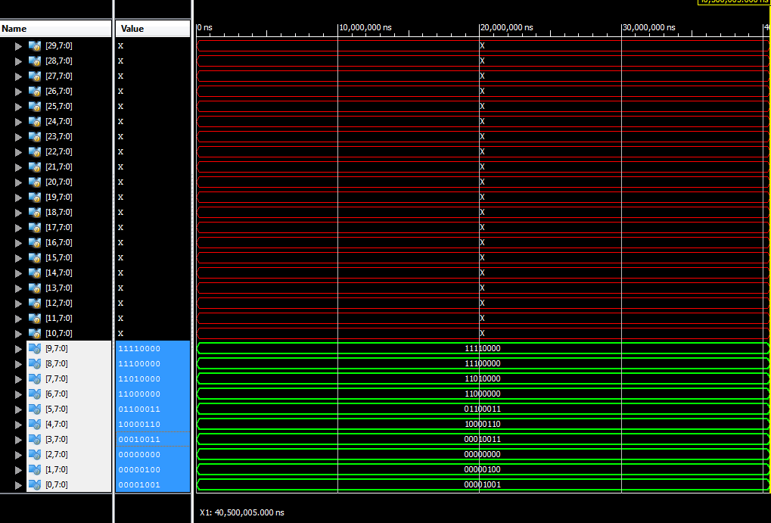

Waveform for sampleseq.code:

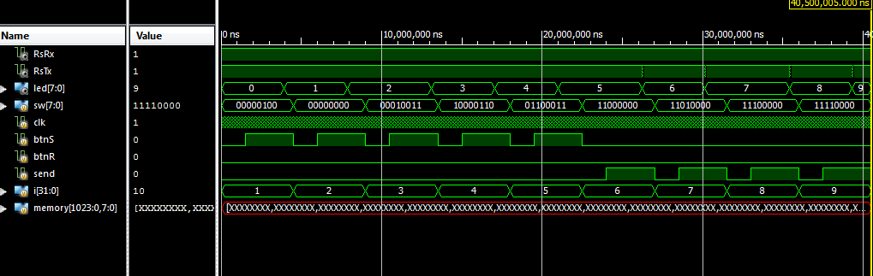

Putty output (addition and multiplication):

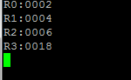

1. Store 2 into R0
2. R0+R0=R1
3. R0+R1=R2
4. R1*R2=R3

Block diagram of seq_alu:

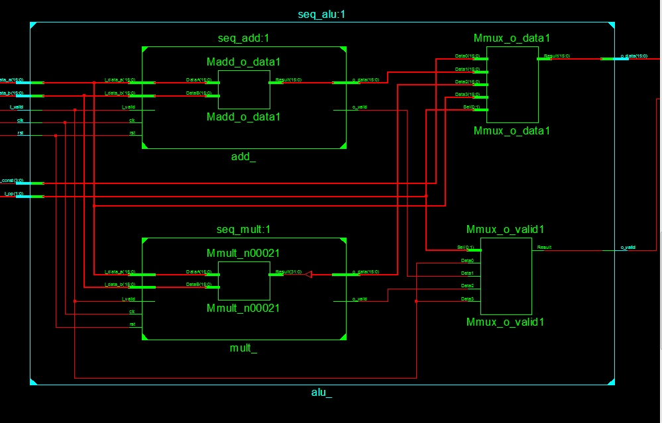

Top level block diagram:

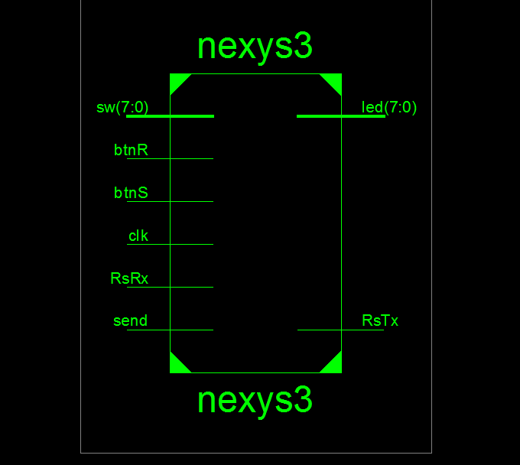

Send button debouncing:

